HEALTHCARE PREDICTIVE ANALYTICS
Predicting Diabetes Risk Using Machine Learning Classification Models
A Project Report Submitted for
Data Analytics Internship — CodTech Technologies
Submitted by: [Your Full Name]
Roll No / Registration No: [Your Roll Number]
College / Institution: [Your College Name]
Course: [Your Course / Branch]
Date: August 2026

1. Introduction
Diabetes mellitus is one of the most widespread chronic diseases globally, and early risk detection is critical for timely intervention and better patient outcomes. Traditional diagnosis relies on clinical tests interpreted by physicians, but data-driven predictive analytics can act as a powerful screening aid — flagging high-risk patients earlier and supporting clinical decision-making at scale.
This project applies supervised machine learning classification techniques to the Pima Indians Diabetes Dataset to predict whether a patient is likely to have diabetes based on diagnostic clinical measurements. The project follows the complete data analytics lifecycle: data acquisition, cleaning and normalization, exploratory data analysis, model building, performance evaluation, and feature importance interpretation — while explicitly addressing the ethical responsibilities involved in handling patient health data.

2. Objectives
- To acquire and clean a real-world clinical dataset relevant to diabetes risk.
- To normalize medical records so that all features contribute fairly to the model.
- To explore the data visually and statistically to understand feature relationships.
- To build and compare multiple classification models for diabetes risk prediction.
- To identify which clinical features most strongly influence the prediction (feature importance).
- To document ethical data-handling practices and patient privacy safeguards followed throughout the project.

3. Dataset Description
Dataset: Pima Indians Diabetes Database.
Original data source: National Institute of Diabetes and Digestive and Kidney Diseases (NIDDK), USA.
Official repository (UCI Machine Learning Repository): https://archive.ics.uci.edu/dataset/34/diabetes
Official mirror (Kaggle, published by the UCI Machine Learning account): https://www.kaggle.com/datasets/uciml/pima-indians-diabetes-database
Citation: Smith, J.W., Everhart, J.E., Dickson, W.C., Knowler, W.C., & Johannes, R.S. (1988). "Using the ADAP Learning Algorithm to Forecast the Onset of Diabetes Mellitus." Proceedings of the Symposium on Computer Applications in Medical Care, 261-265.
The dataset contains 768 real, individually-measured patient records and 8 clinical input features, with a binary target variable "Outcome" (1 = diabetic, 0 = non-diabetic). All patients are female and at least 21 years of age, of Pima Indian heritage. These are original diagnostic measurements collected by NIDDK, not synthetic or model-generated values. The dataset is fully de-identified and is one of the most widely used public benchmarks for medical machine learning research, cited in hundreds of peer-reviewed studies.

3.1 Feature Description
- Pregnancies — Number of times pregnant
- Glucose — Plasma glucose concentration (2-hour oral glucose tolerance test)
- BloodPressure — Diastolic blood pressure (mm Hg)
- SkinThickness — Triceps skinfold thickness (mm)
- Insulin — 2-Hour serum insulin (mu U/ml)
- BMI — Body Mass Index (weight in kg / (height in m)^2)
- DiabetesPedigreeFunction — A function that scores likelihood of diabetes based on family history
- Age — Age in years
- Outcome — Target variable (1 = Diabetic, 0 = Non-Diabetic)

4. Methodology

4.1 Data Cleaning and Normalization
On inspection, several clinical fields (Glucose, Blood Pressure, Skin Thickness, Insulin, and BMI) contained biologically impossible zero values — a value of zero for blood glucose or BMI is not medically valid and indicates a missing measurement rather than a true reading. These were converted to missing values and imputed using the column median, which is robust to outliers and standard practice for clinical vitals. The table below summarizes the missing data handled:
Feature | Missing (as invalid 0) | % of Records
Glucose | 5 | 0.7%
BloodPressure | 35 | 4.6%
SkinThickness | 227 | 29.6%
Insulin | 374 | 48.7%
BMI | 11 | 1.4%

After cleaning, all input features were standardized using z-score normalization (StandardScaler), transforming each feature to have zero mean and unit variance. This step is essential for distance-based and gradient-based models such as Logistic Regression and Support Vector Machines, ensuring that features measured on different scales (e.g., Insulin in mu U/ml vs. BMI) contribute fairly to the model rather than a feature with a naturally larger numeric range dominating the result.

4.2 Exploratory Data Analysis (EDA)
Before modeling, the dataset was explored visually to understand class balance, feature correlations, and how individual clinical measurements differ between diabetic and non-diabetic patients.
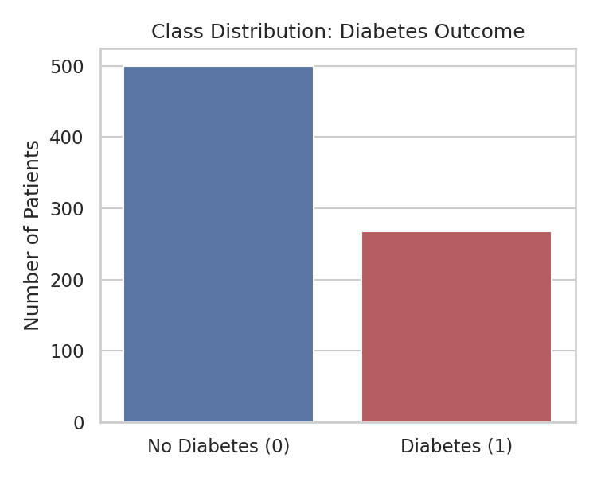
Figure 1: Class distribution of the target variable (Outcome).
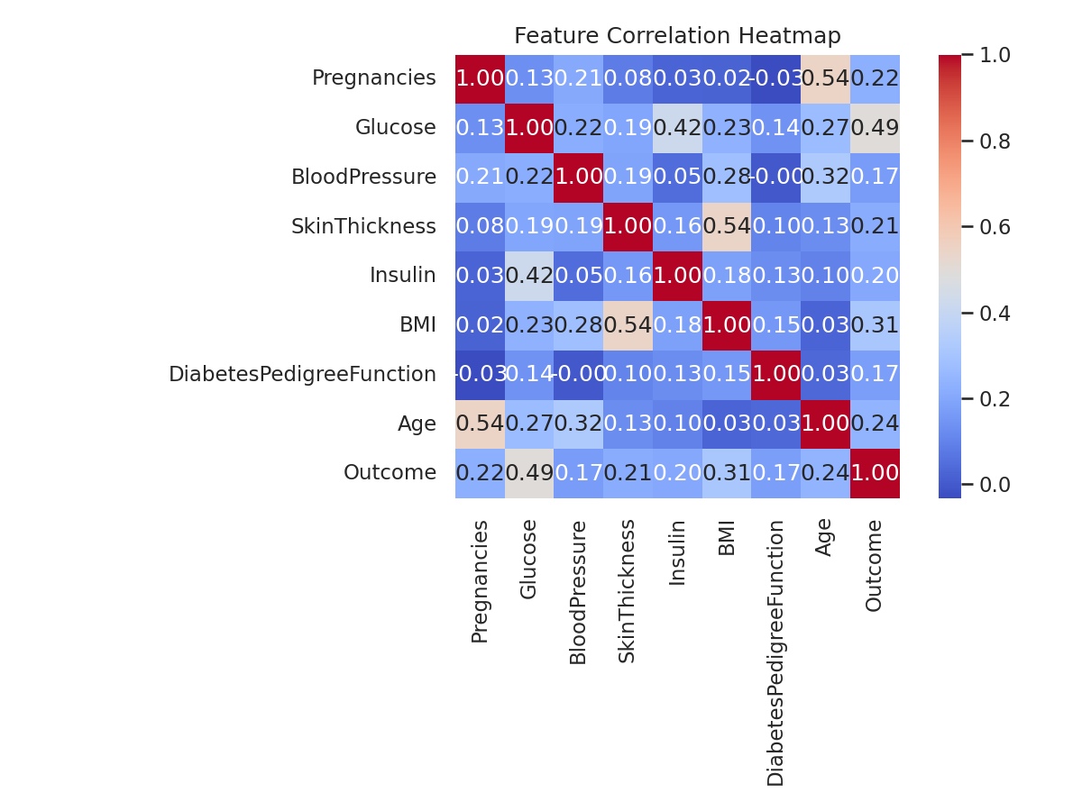
Figure 2: Correlation heatmap of all clinical features.
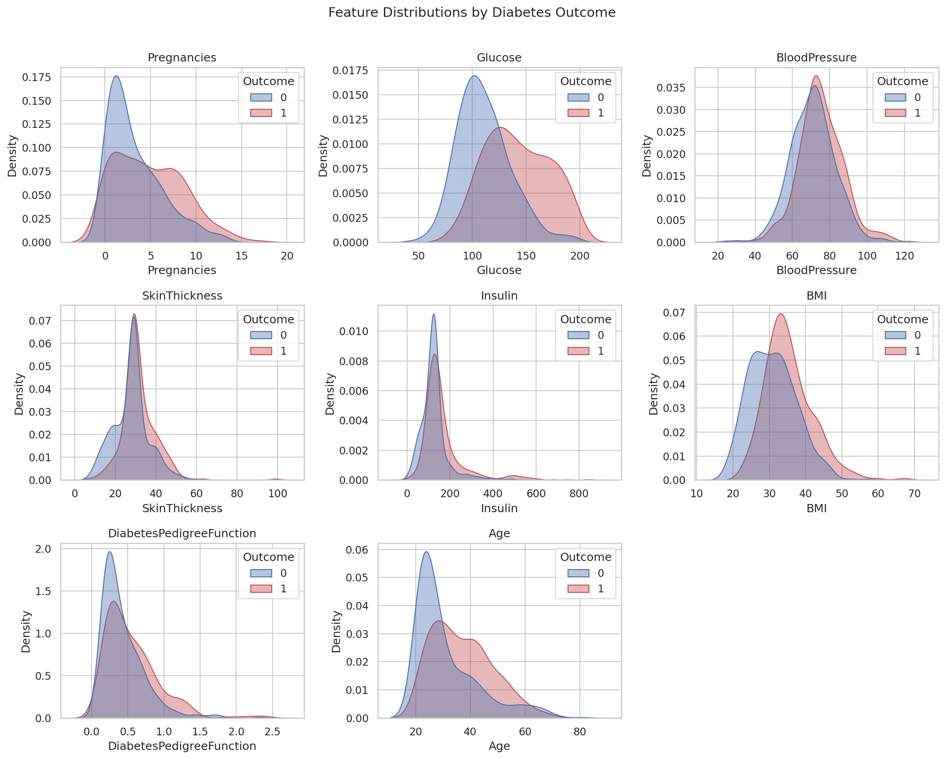
Figure 3: Distribution of each clinical feature, split by diabetes outcome.
Glucose shows the strongest visible separation between diabetic and non-diabetic patients, followed by BMI and Age — an early visual signal that is later confirmed quantitatively through feature importance analysis.

4.3 Train-Test Split
The cleaned dataset was split into training and testing subsets using an 80:20 ratio with stratified sampling to preserve the original class proportions in both sets. This resulted in 614 patients for training and 154 patients held out for testing.

4.4 Classification Models Applied
Four classification algorithms were trained and compared, representing a range of modeling approaches — from an interpretable linear baseline to ensemble and kernel-based methods:
- Logistic Regression — a linear, highly interpretable baseline model.
- Random Forest — an ensemble of decision trees, robust to noise and non-linear relationships.
- Support Vector Machine (RBF kernel) — effective for complex, non-linear decision boundaries.
- XGBoost — a gradient-boosted tree ensemble, typically state-of-the-art on tabular clinical data.
Each model was evaluated using 5-fold stratified cross-validation on the training set (to check stability) and then tested on the held-out test set for a final unbiased performance estimate.

4.5 Evaluation Metrics
Because misclassifying a diabetic patient as healthy (a false negative) is clinically more dangerous than a false alarm, multiple complementary metrics were used rather than accuracy alone:
- Accuracy — overall proportion of correct predictions.
- Precision — of patients predicted diabetic, how many actually are (avoids over-alarming healthy patients).
- Recall (Sensitivity) — of patients who are actually diabetic, how many the model correctly identifies (critical in healthcare, to minimize missed cases).
- F1-Score — harmonic mean of precision and recall, balancing both concerns.
- ROC-AUC — measures the model's ability to distinguish between classes across all thresholds.

5. Results

5.1 Model Performance Comparison
Model | Accuracy | Precision | Recall | F1-Score | ROC-AUC
Logistic Regression | 0.7078 | 0.6 | 0.5 | 0.5455 | 0.813
Random Forest | 0.7338 | 0.6512 | 0.5185 | 0.5773 | 0.8081
Support Vector Machine | 0.7403 | 0.6522 | 0.5556 | 0.6 | 0.7964
XGBoost | 0.7662 | 0.68 | 0.6296 | 0.6538 | 0.8244

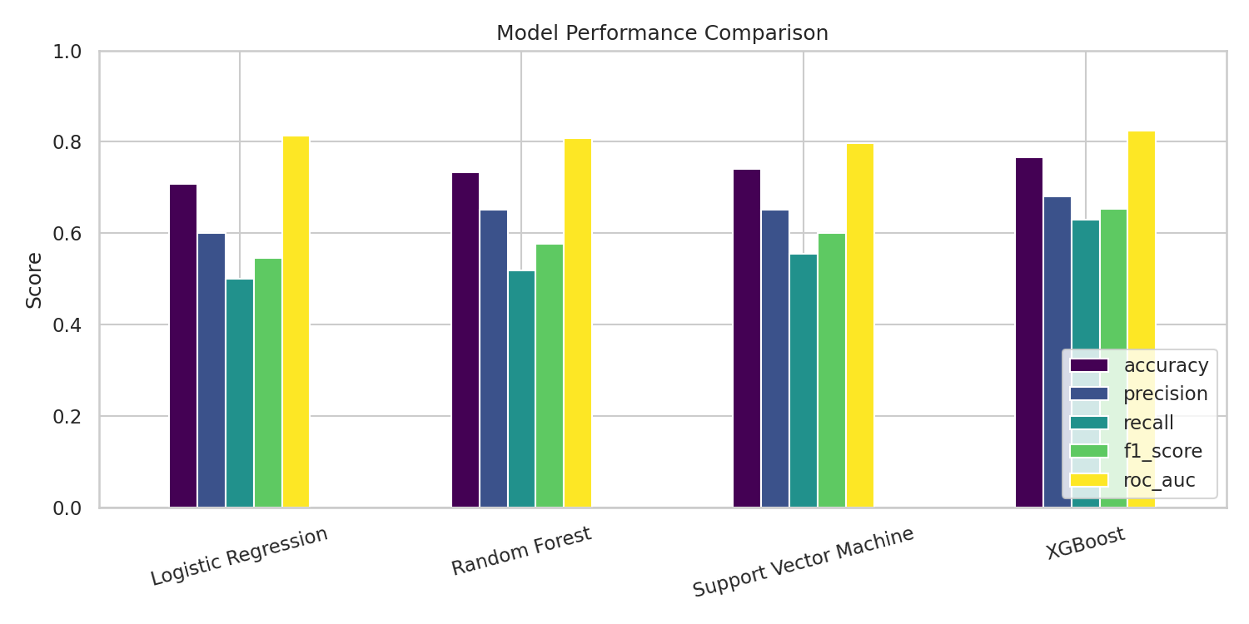
Figure 4: Bar chart comparison of all evaluation metrics across models.
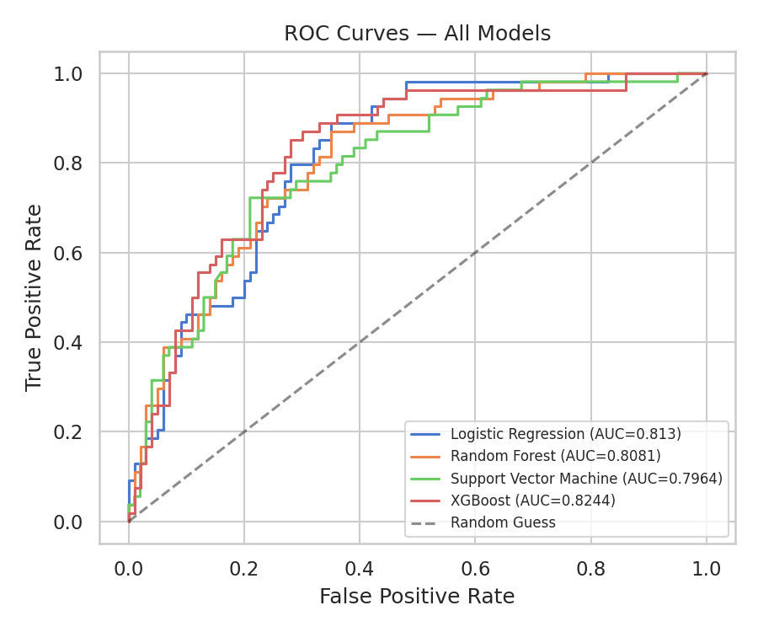
Figure 5: ROC curves for all four models.
Based on ROC-AUC — the most robust metric for imbalanced medical classification tasks — XGBoost performed best, achieving an accuracy of 76.6%, recall of 63.0%, and ROC-AUC of 0.8244. Its 5-fold cross-validation accuracy of 74.9% (± 1.3%) indicates stable performance across different data splits, rather than a result driven by a lucky train-test split.

5.2 Confusion Matrices
Confusion matrices show exactly how each model's predictions break down against the true outcomes on the test set.
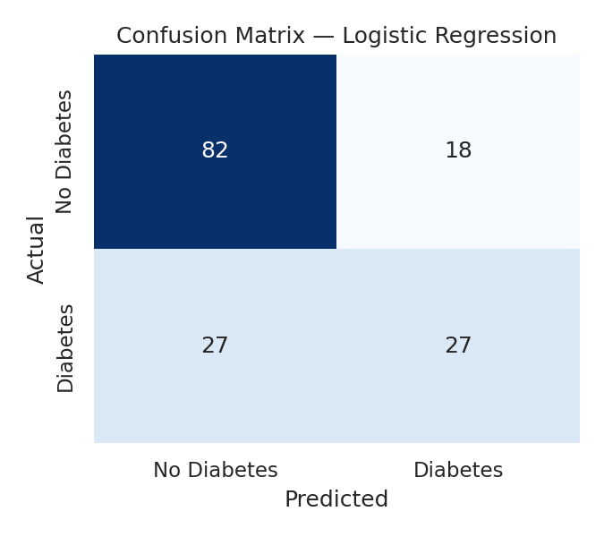
Figure 6a: Confusion Matrix — Logistic Regression
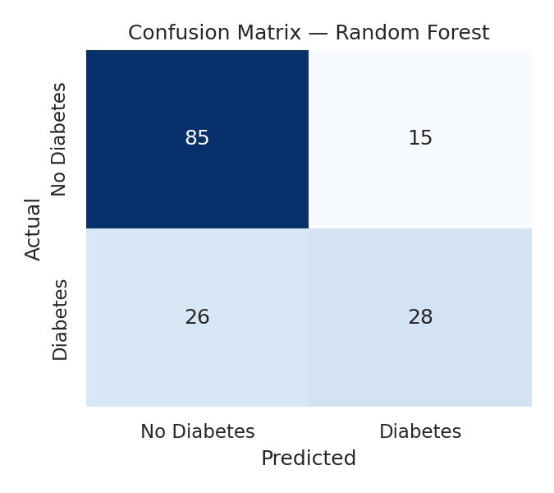
Figure 6b: Confusion Matrix — Random Forest
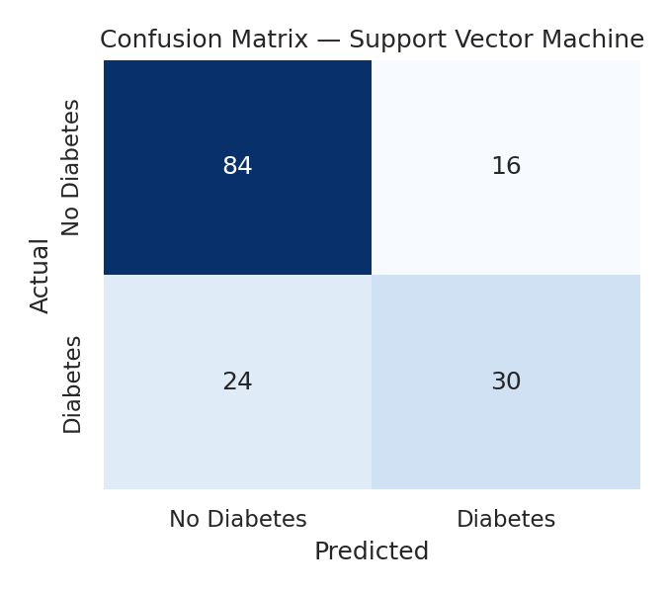
Figure 6c: Confusion Matrix — Support Vector Machine
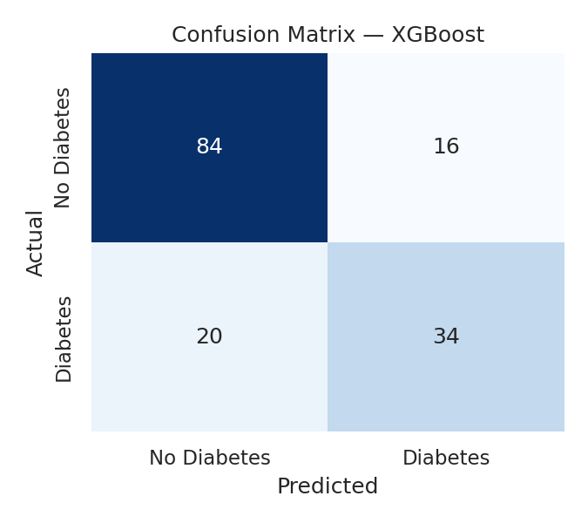
Figure 6d: Confusion Matrix — XGBoost (Best Model)

6. Feature Importance Analysis
Understanding which clinical features drive the model's predictions is essential in healthcare — it builds clinician trust and can highlight which measurements are most worth prioritizing during screening. Feature importance was computed three ways: Random Forest's built-in importance, XGBoost's gain-based importance, and the absolute standardized coefficients of Logistic Regression.
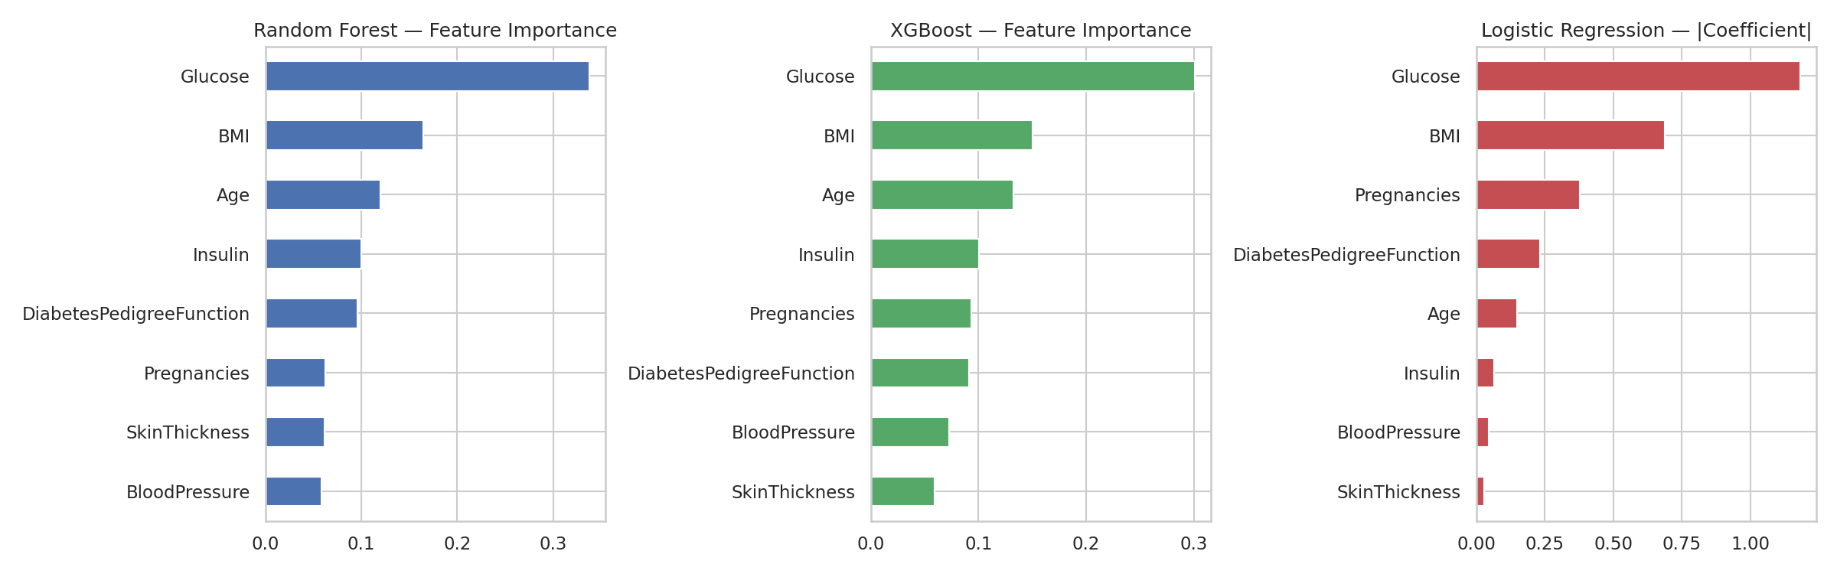
Figure 7: Feature importance comparison across Random Forest, XGBoost, and Logistic Regression.
Rank | Feature | Random Forest Importance
1 | Glucose | 0.3377
2 | BMI | 0.1644
3 | Age | 0.1203
4 | Insulin | 0.0999
5 | DiabetesPedigreeFunction | 0.0957

All three models consistently agree that Glucose level is by far the strongest predictor of diabetes, followed by BMI and Age. This aligns with established clinical understanding: elevated blood glucose is the direct diagnostic marker of diabetes, while high BMI (obesity) and older age are well-documented risk factors for Type-2 diabetes. This consistency between the data-driven results and known medical knowledge is a good sanity check on the model's validity.

7. Ethical Considerations and Patient Privacy
Working with health-related data carries responsibilities beyond model accuracy. The following safeguards and principles were followed throughout this project:
- De-identified data only: the dataset used contains no patient names, addresses, or any personally identifiable information — it is a fully anonymized public research dataset.
- Local, contained processing: all data cleaning, training, and evaluation were performed within a controlled analysis environment; no patient-level record was shared with an external party.
- Aggregate, not individual, reporting: every result presented in this report — metrics, charts, and importance scores — describes group-level model behaviour, never a single traceable patient.
- Population bias awareness: this dataset is drawn from a specific population (adult females of Pima Indian heritage). A model trained on it should not be assumed to generalize to other populations (different ethnicities, sexes, or age groups) without re-validation and a fairness audit.
- Decision-support, not diagnosis: this model is intended purely as a screening / decision-support aid. It must never replace a licensed medical professional's diagnosis, and any real-world use requires clinician oversight.
- Regulatory & consent compliance: any extension of this project to real hospital data would require informed patient consent, institutional ethics/IRB approval, and compliance with applicable health-data protection law — for example India's Digital Personal Data Protection (DPDP) Act 2023, HIPAA in the United States, or GDPR in the European Union.
These principles reflect the broader responsibility that comes with applying data analytics to healthcare: the goal is to support better, faster, and fairer patient outcomes — never to compromise patient privacy or replace clinical judgment.

8. Conclusion
This project successfully demonstrates an end-to-end healthcare predictive analytics pipeline for diabetes risk detection. After cleaning and normalizing the clinical dataset, four classification models were trained and rigorously compared. XGBoost emerged as the best-performing model with a ROC-AUC of 0.8244, and feature importance analysis consistently identified Glucose, BMI, and Age as the most influential predictors — findings that align closely with established medical knowledge on diabetes risk factors. Beyond model performance, the project emphasizes that responsible healthcare analytics must be built on a foundation of data privacy, bias-awareness, and clear boundaries around the model's role as a decision-support tool rather than a replacement for clinical diagnosis.
As future work, this pipeline could be extended with hyperparameter tuning (e.g., GridSearchCV), SHAP-based explainability for individual predictions, and validation on additional datasets (such as heart disease or other UCI clinical datasets) to test generalizability across conditions.

9. References
1. Smith, J.W., Everhart, J.E., Dickson, W.C., Knowler, W.C., & Johannes, R.S. (1988). "Using the ADAP Learning Algorithm to Forecast the Onset of Diabetes Mellitus." Proceedings of the Symposium on Computer Applications in Medical Care, 261-265. (Original dataset publication, NIDDK.)
2. UCI Machine Learning Repository — Pima Indians Diabetes Database: https://archive.ics.uci.edu/dataset/34/diabetes
3. Kaggle — Pima Indians Diabetes Database (UCI Machine Learning mirror): https://www.kaggle.com/datasets/uciml/pima-indians-diabetes-database
4. Pedregosa et al., "Scikit-learn: Machine Learning in Python," Journal of Machine Learning Research, 2011.
5. Chen, T. & Guestrin, C., "XGBoost: A Scalable Tree Boosting System," KDD 2016.
6. Digital Personal Data Protection Act, 2023, Government of India.

